Attributes | Parameter Value
Product Category | USB Connector
Connector Type | Type-A
Standard | USB 2.0
Gender | Female Connector
Number of Contacts | 4
Number of Ports | 1

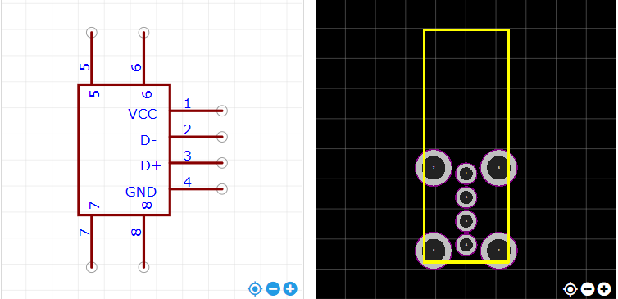

https://item.szlcsc.com/26978.html

